1. **Using canvas**: when the user clicks on the “click me” button generate number of circles in the entire page in random places and get the circles color from the “input color”.

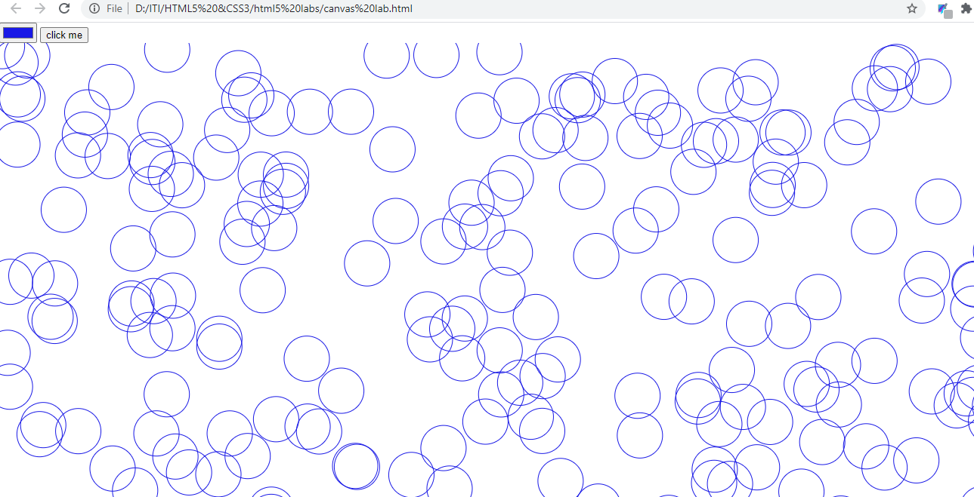

**CSS3 lab**

2- Using font awesome CDN to create the icons

https://stackpath.bootstrapcdn.com/font-awesome/4.7.0/css/font-awesome.min.css"

**icons html code:**  
<i class="fa fa-bullhorn"></i>

<i class="fa fa-comments"></i>

<i class="fa fa-cloud-download"></i>

<i class="fa fa-leaf"></i>

<i class="fa fa-cogs"></i>

<i class="fa fa-heart"></i>



3- Hovering on colored div makes it larger and give it shadow with a transition 1 sec

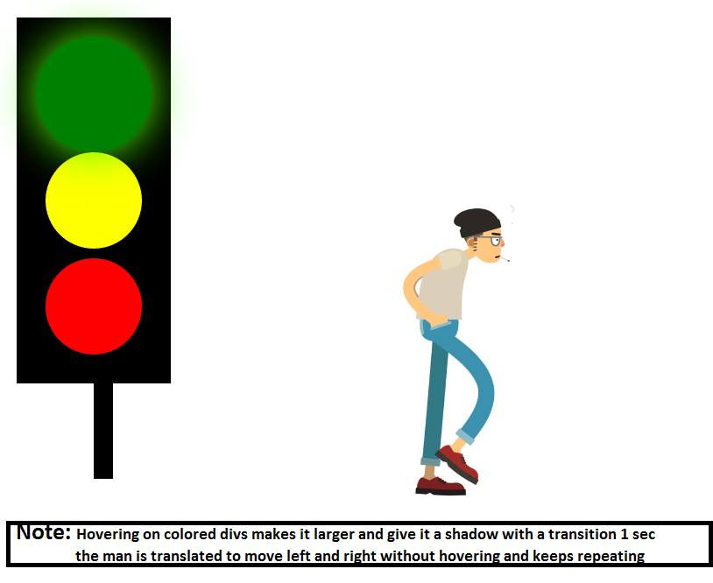

1. Bonus: check this site to draw the shape below

<https://css-tricks.com/the-shapes-of-css/>

